Preschool Handbook
C CHR I S T U N I T E D M E T H O D I S T C H U R C H

Vision Statement of Christ United Methodist Church

The Vision of Christ UMC is to be a beacon of light, love and hope in the community.
.

Mission Statement of the Preschool

Christ preschool strives to provides children a happy, safe environment to learn about God’s love and to grow socially, emotionally, spiritually, physically and intellectually into amazing little people.

We strive to meet your child’s needs in the following ways:
LOVE AND SECURITY – holding and talking to your child often, offering physical affection as well as verbal affirmation; telling your child that we’re glad he/she is here.

HEALTHY SELF-CONCEPT – noting verbally your child’s abilities and gifts, letting your child work at his/her own pace, talking about feelings and different ways to problem solve and deal with frustrations, encouraging your child to make his/her own decisions, letting your child choose activities, letting your child take responsibility for the room.

PHYSICAL NEEDS – providing activities such as building with blocks, working puzzles, stringing beads, painting, cutting with scissors, running, jumping, dancing, catching a ball, pedaling riding toys.

LEARNING BY EXPERIENCING – We believe children learn by doing. Therefore, we offer the following opportunities for skill development.

SOCIAL SKILLS – learning to relate to the group, doing things independently, standing up for personal rights, learning how to share and waiting for a turn.

LANGUAGE SKILLS – joining in nursery rhymes and songs, relating experiences, describing events, encouraging self-expression in a courteous manner, learning to use words through sharing experiences.

COGNITIVE SKILLS – becoming familiar with colors, shapes, numbers and recognizing his/her name, making comparisons, recognizing similarities and differences, sorting and matching, following simple directions.

SELF-HELP SKILLS – taking care of his/her person: washing hands, toileting, managing a snack time, taking care of environment; proper use of equipment and toys, cleaning up after activities, taking care of personal clothing, removing/putting on, hanging up or putting in cubbies.

Contact - Christina Lester, Director
704-392-1622
704-617-7175 Mobile
Office Hours 9am-12:30pm M-F
chris@xumc.org

Preschool Hours - 9:00am – 12:30pm
Preschool morning drop-off is from 8:55 until 9:1 0
CUMC Preschool operates from September – May

Preschool Policies

Objectives of the Preschool

Our goal at Christ UMC Preschool is to provide a developmentally based Christian curriculum that nurtures a child’s growth; socially, emotionally, physically, intellectually, and spiritually. Your child will learn through active play, in an environment set up for learning through fun activities with developmentally appropriate social interaction with their peers and preschool staff.

Registration

The annual registration fee for Fall preschool is $100.00. Second sibling registration fees are $75.

Registration fees must be paid in full at time of registration and are non-refundable.
If a parent/guardian registers their previously enrolled child during the in-house registration period and in good faith anticipates enrolling a brother or sister in the upcoming sibling registration and the sibling’s desired class is full, Christ UMC Preschool will refund the previously enrolled student’s registration fee.

Space cannot be guaranteed for returning students if your application is not completed and the registration fee is paid. Pre-registration for the following school year typically begins in early spring. Pre-registration dates will be advertised throughout the preschool and community. Classes fill on a first come, first serve basis with a paid registration fee. New families schedule a time for a tour and preschool visit with their child prior to enrollment to determine if the program is a good fit for their child. Christ Preschool reserves the right to determine if they will be able to accommodate all students.

Tuition
One Day a Week= $150/month
Two Days per Week = $195/month
Three Days per Week = $265/month
Four Days per Week = $325/month
Five Days per Week = $385/month
Christ UMC Preschool is a Non- Profit Organization

Tuition is due by the first business day of each month.
Tuition is due for the entire month if a student attends any days during that month. IF you plan to travel for a month and then return, tuition must be paid to hold your students spot in the classroom. There is a $25 late charge applied to the families account once tuition is past due. If tuition is still past due on the first day of the next month, the child may not attend until the balance has been paid.

There is charge on all returned checks equal to the charge made by the bank to the Preschool. When a check is returned, we ask for the payment to be made in cash.

Payment can be made 3 ways:
- Checks should be made payable to “Christ United Methodist Church” and marked with the child’s name(s) and the month(s) for which you are paying. An adult should submit the payment to the director.
- Families may pay with exact change in cash to the director.
- You may pay online through the Jackrabbit parent portal. Tuition fees are posted by the 15th of the month for the next month and are due by the 1st of the month. Tuition can be set to be withdrawn from your bank account on the 15th of the month prior to when the payment is due or on the first business day of the month.

Parents are expected to be prompt in paying all tuition. Tuition is used to pay our teachers and to purchase needed supplies for school. Should your family experience a financial emergency, we urge you to speak promptly to the Director. Please do not wait until there is a late charge due to a missed payment. Such information will be held in strict confidence. Consistently late or unpaid tuition will result in dismissal.

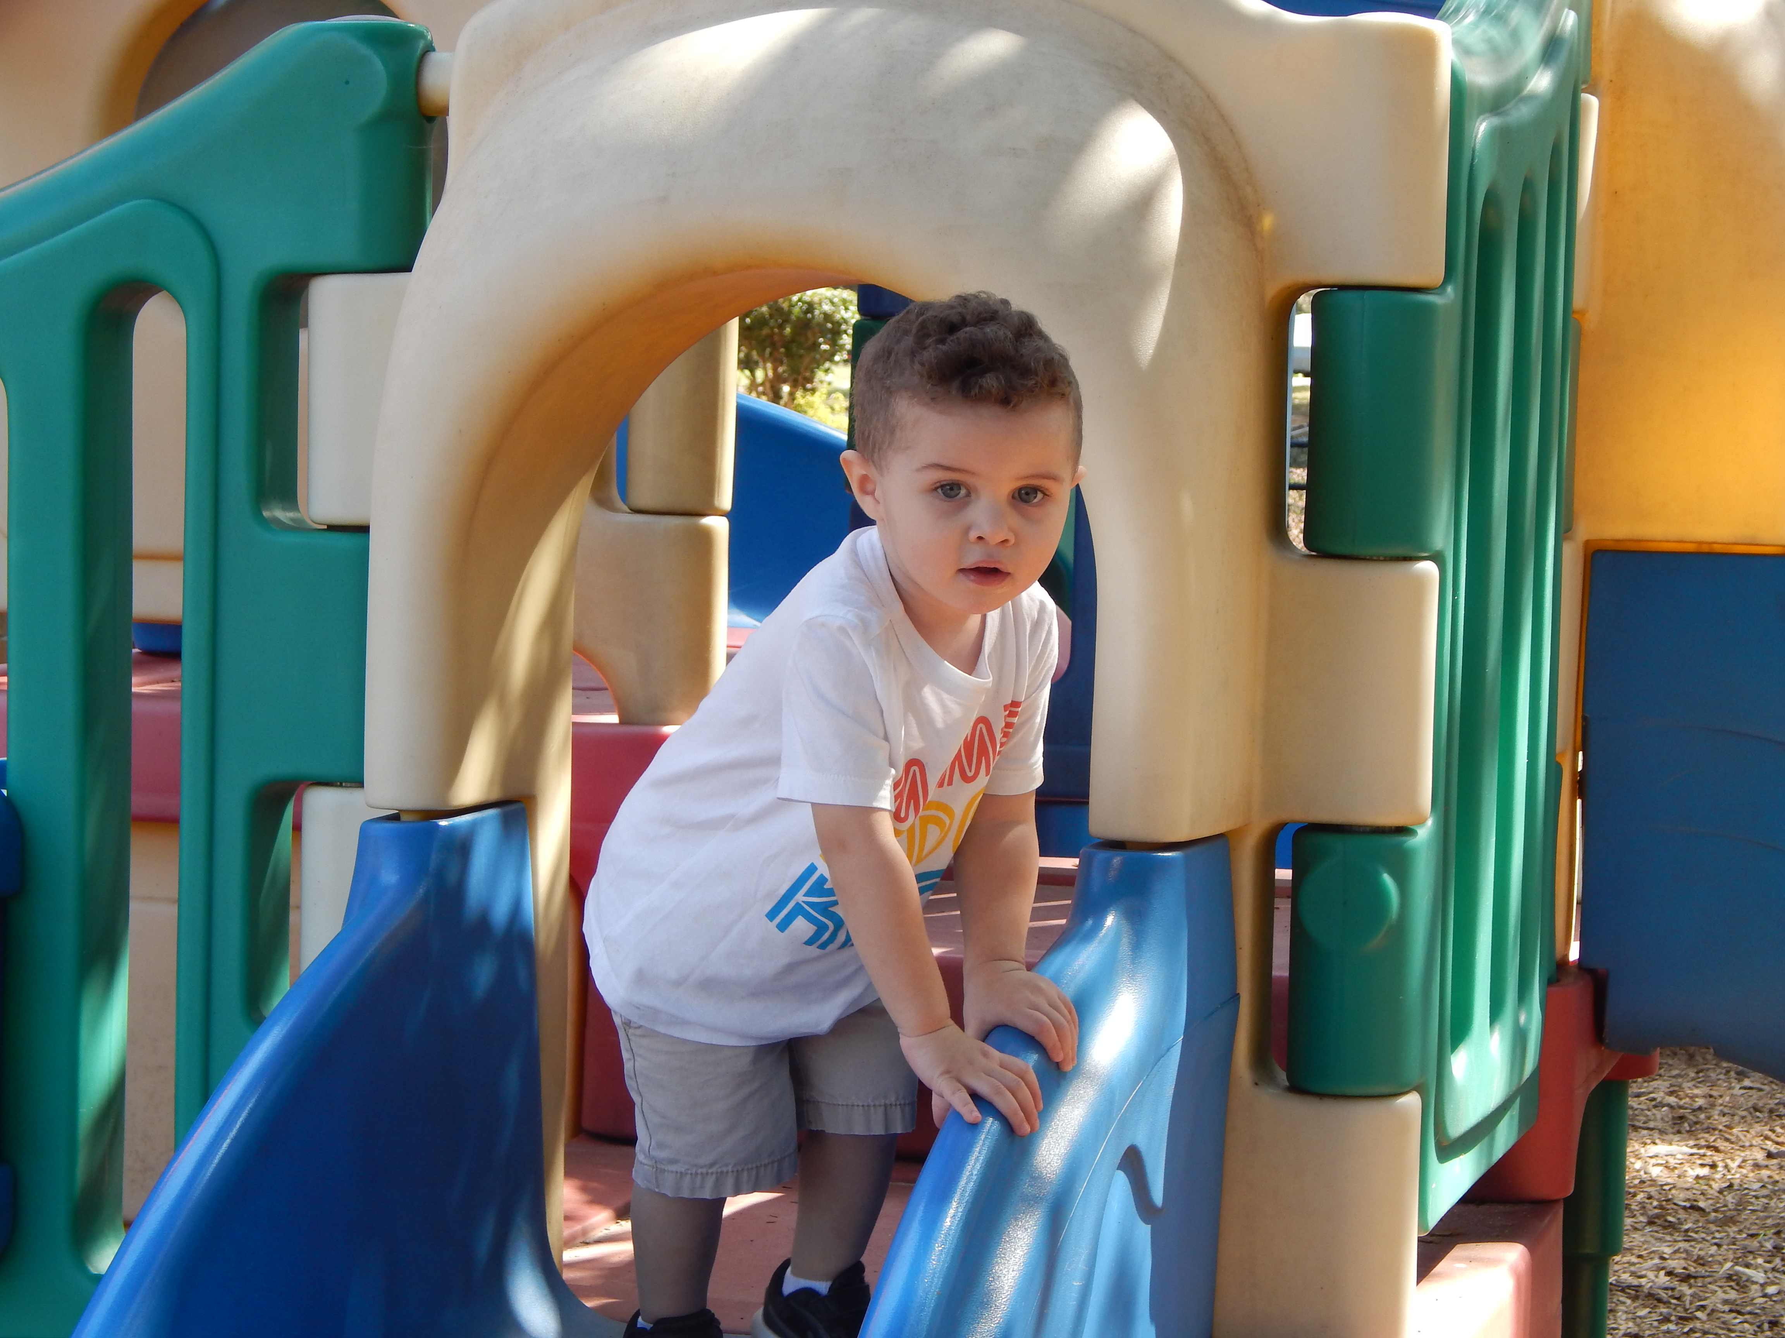
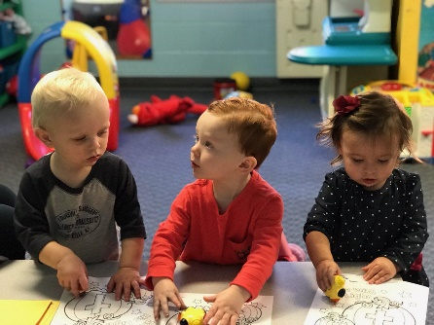
Admission

The preschool accepts children who are age 1 years as of December 31st through 5 age years. We use the North Carolina state school cut-off date of August 31, to determine class placement in all classes except the older ones/young twos class.

Only children who are walking, have given up their morning naps and who can eat independently will be enrolled in the Wonderful Walkers class. Diapers and wipes must be provided by parents. Children age three and above should be toilet trained. If you are in the process of toilet training, the child must wear Pull-Ups or a disposable training pant to school.

If we are not equipped to give your child extra needed attention to be successful in the program, we will make every effort to assist the parent in locating another appropriate program. We have the right as a preschool program to refuse any student that we feel could impact the success of all students in the classroom. Children and staff should be able to thrive in a positive, safe, warm nurturing environment.

A copy of your children’s immunization record is required by the first day of school. Registration applications online include an allergy permission section. Parent signatures and Benadryl dosage amounts are required in writing on an additional form in the event of a student allergy emergency at preschool.

Preschool Allergy Policy

All parents will fill out an online and written student allergy form for students with identified allergies. The allergy form will describe the child’s specific allergy, symptoms, and procedures; including medicines and dosage amounts to be administered by preschool staff. The document will be signed by the parent, the child’s physician, and the preschool teacher.

Parents are required to review this document face to face with the director and a classroom teacher before the teacher will be responsible for the child’s participation in the classroom.

We have a preschool community policy that ALL student’s first and last names and allergens will be posted in a visible place in the classrooms. Nut products can be banned from individual classrooms for a student with a severe nut allergy.

Attention should be given to content packaging. If the item is produced in a facility where nuts are manufactured, the item is not considered nut-free. A publication will be distributed at the beginning of the year anonymously informing all parents of the student allergies in the classroom.

Food brought to the school for special occasions should be store bought and individually wrapped and will be coordinated with the teacher.

Parents of students with severe allergies have the option to attend special events when there is the possibility of altering the recommended student-teacher ratios in the classroom. This option continues to be available at parent request and all special treats must be store bought and are encouraged to be individually packaged due to allergies.

Preschool student registration forms include a permission option; with parent signatures and dosage amounts, for preschool staff members to administer Benadryl in an unexpected student allergy emergency.

Because it is impossible to predict the reaction to an allergy related incident, parents will be asked to provide an Epi Pen for any child that has tested positive with any type of allergy.

Rain Day Drop off and Pick Up (All ages)
We do not ask staff to stand in the rain and load or unload children to/from cars. This is because we do not have a covered walkway in the front of the preschool building. We ask ALL parents to please park and both bring in students and come collect your student from the family life center area on rainy days. We have a rainy day sign that is usually out to remind you about the change if you drop off/pick up in the front of the building.

Normal Morning Drop Off :
Wonderful Walkers, Terrific Talkers and Three’s Classroom
Preschool drop off is between 8:55am and 9:10am. Doors are opened at 8:55am and locked at 9:10am. Please be prompt in dropping off your child/children. Our staff will greet you and guide your little one to their classroom. Our daily classroom schedule allows for 30 minutes of center time play before we move to other activities. It is disruptive to the classroom if students are late, and they miss out on fun center time play. Around January each year the Three’s classroom will begin to follow the Morning drop off routine list below for the Pre-K. This is to help students begin to be more independent.

Morning Drop Off :
Pre- K
The Pre- K classroom students will be walking into the classrooms independently with teacher supervision. This drop off location is at the front of the preschool wing. Drop off time is from 8:55am – 9:10am after that time parents need to park and walk the child to the front doors.

Normal Afternoon Pick Up Routines-
Pick Up Time 12:30 pm

Pre-K: Parent’s pick up in the front of the preschool building. Students should load and unload on the passenger side of the vehicle. Parents should stay in the car while the students are loaded and then pull forward towards the sidewalk in front of the church to have/assist students bucket into their car seats.

Walkers, Talkers and Thoughtful Three’s: Parent’s should enter the back of the parking lot from the Oakridge Road entrance. Do not enter our parking lot off of Belhaven Blvd during afternoon carline. This is for safety reasons; the parking lot is one way and it is unsafe to drive past the car line as we are loading students. So please head around the block to collect your child daily. Parents should stay in the car while the students are loaded and then pull forward towards or into a parking spot to assist students bucket into their car seats.

- Please let us know if someone different will be picking up your child. If possible,
let the teacher know the type and color of the vehicle driven and please make
sure, that your child is also aware of any change in his/her regular pick-up
schedule if you know ahead of time.
- Please be prompt in picking up your child/children from school.
- Children get upset/ worried if they are picked up late. Let us know if you
will be late for some unavoidable reason then we can prepare your
child.
- Families who are consistently late will be charged a late fee. Dismissal time is
12:30pm and you are considered late after 12:40pm.
- After 12:40pm there could be a late fee of $5, after 12:50pm the late fee becomes $10, after 1 pm there is a $20 late fee. The fee is due within one week of the late incident and will be added to your account by the director.

REMINDER
TEACHERS WILL BRING STUDENTS TO THE CAR TO LOAD. WE DO NOT BUCKLE STUDENTS INTO CAR SEATS. PARENTS, PLEASE STAY IN THE CAR UNTIL THE CHILD IS LOADED ON THE PASSENGER SIDE. THEN YOU CAN PULL FORWARD, PARK AND GET OUT TO BUCKLE YOUR CHILD INTO THEIR CARSEAT.

STUDENTS MUST HAVE A CARSEAT TO BE PICKED UP.

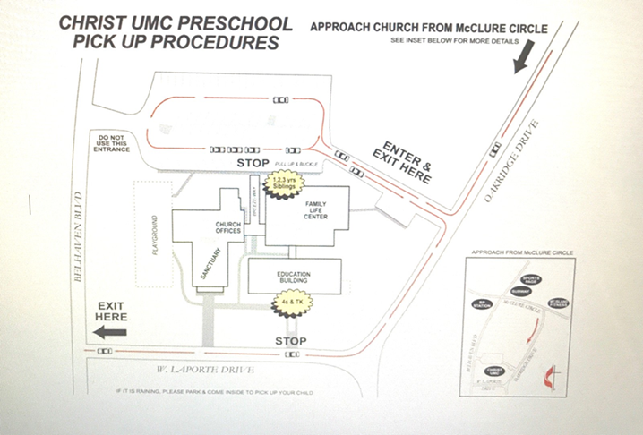

PRE-K FAMILIES- PLEASE DO NOT USE THE CHURCH PARKING LOT AS A CUT THROUGH TO GET TO YOUR CAR LINE. THIS IS FOR SAFETY REASONS, PLEASE COME DOWN THE STREET USING OAKRIDGE DRIVE TO GET TO WEST LAPORT DRIVE

Parent Conferences

Arrival and Dismissal times are not times for a serious conference, at that time teachers are needed to supervise and interact with all of the children in their responsibility. Teachers welcome and invite parents to set a time for in person or phone conferences. If this conference does not seem to help, then contact the director and arrange for a joint conference with the teacher and director.

Clothes and Personal Belonging

Every child should have a complete change of clothing to be left at the church or in their book bag. All backpacks, sweater, jackets, cups (top and bottom), books, etc. should be plainly labeled with children’s name. Clothing should be washable and durable since the children will get messy when playing outside and doing “messy” art.

Shoes should be appropriate for active play. Comfortable closed toe shoes are recommended as sandals and boots can be uncomfortable and hazardous on the playground. Water bottles labeled with your child’s name are recommended.

Preschool Lunches

Children bring their lunches from home (including a drink) to school every day. Please
send simple items that children can eat independently. Consider leaving dessert type
items at home to eat later, as children will often want to eat these items first. If possible, leftover items will be sent home in the lunch box so that you can see what your child ate. Students should also bring a refillable water bottle (filled with water) labeled with their name for the gym/playground daily.

A publication will be distributed at the beginning of the year anonymously informing all parents of the student allergies in each classroom. We expect all families to participate in a safe classroom environment.

Special Celebrations

- Notify your child’s teacher if you would like to bring food in celebration of your child’s birthday at preschool.
- We need to know which day you plan to celebrate and what you plan to bring due to possible allergies in the classroom.
- All food items must be store bought, labeled with ingredients and prepackaged.
Goodie bags should be age appropriate with nonfood items only.
- Please no party invitations delivered at the preschool unless the entire classroom is invited, children who are not invited feel very left out.
- Thank You so much for being considerate of the other children’s feelings.

School-wide Special Events

Christ UMC Preschool does not offer off campus field trips. However, various
community resources are scheduled each year to visit the preschool. Some of these
include, a monthly librarian visit, bi-monthly Chapel Chats with the Pastor,
Firetruck/Police car visits, and usually several other special guest events supported
by preschool fundraising events. We also have a Trunk or Treat event sponsored by
the church and Fall, Christmas, Valentines and Spring class parties.

Parent Involvement and Fundraising

We love our preschool parents and preschool parents are offered opportunities to help
with a variety of aspects of preschool, some of these include the following:

- Coordinating Classroom Parties (Fall, Christmas, Valentines, Easter)
- Preschool Picture Day
- Provide volunteer support for special activities
- Help coordinate fundraising for the preschool
- Teacher Appreciation Week- Luncheon
- Scholastic Books Orders

In coordinating parties, please discuss all possible food allergies with the classroom teachers and make sure ALL volunteers/parents are aware of food allergies. Some years that will include a nut free classroom.

School Safety

Christ United Methodist Church has 4 different buildings. The preschool buildings doors are kept locked at all times other then, at drop off and pick up daily. Church personal and
preschool staff are the only individuals typically in the building on a daily basic. All staff wear Preschool Id’s and have keys to maintain your child’s safety.

Emergency Drills

Fire drills are conducted monthly. Fire evacuation plans will be practiced in each
classroom. Obviously, we hope that there will never be a need for evacuation, but we will
take necessary precautions and be prepared at all times. We do not have tornado drills
throughout the year, but staff are trained on where to go and what to do if there are
tornado concerns while school is in session. We also have plans in place for other emergency occurrences such a tornado, and a building lockdown..

Clean Preschool

Our preschool classrooms, doors and restrooms are cleaned daily by our church
custodian. We also have deep cleaning which occurs several times throughout
the year. Teachers clean their classroom during the day as children complete
activities and wipe rooms down at the end of the day. Appropriate handwashing is taught and hand washing is encouraged at all age levels.

Safe Sanctuary/First Aid/CPR Training

The United Methodist Church has a Safe Sanctuary policy that guides teachers, employees, and volunteers to operate in a manner that is safe for themselves and for students. All staff have received training in first aid and immediate medical care and CPR.

Sick Child Policy

We realize children of this age often become ill. As in any situation where many children
are together, contagious illnesses will make their rounds quickly. Preschool-aged children
pick up lots of germs and they spread easily and quickly. Often times, children are
contagious before we even know they have contracted an illness. If you know your child or their sibling has a contagious disease, please do not send him/her to school and always let us know immediately! We would like to be able to inform parents if classmates have been exposed to a contagious illness.

Should your child become ill at school, we will contact you and isolate your child from the
group. If we cannot reach you and deem it necessary, we will pursue the emergency
numbers listed on the registration form. Make sure you list phone numbers in the system not just names. The preschool registration form, which all parents sign, includes a statement authorizing the Director/Teacher to seek emergency medical care in the event that the parents or guardian cannot be contacted immediately.

Preschool staff cannot administer any medication to a child during school hours. The only
exception is emergency medication, such as that for severe allergic reaction where
medication must be administered immediately. A special form must be filled out and kept on file with medication. Please see the director for more information.

Illness/Absences

Please let us know when your child will be absent; especially if it due to illness. We do not pro-rate tuition for illness or absences. Remember to keep your child enrolled, monthly tuition must be paid.

Please do not send a child to school that shows signs of illness, such as fever, sneezing, coughing, runny nose, sore throat, flushed face, headache, rash or diarrhea. If they don’t feel well then preschool will not be fun for them. We understand that some students struggle with allergies but children who have runny noses, watery eyes and coughs from allergies cannot attend the preschool since there is no way to tell the difference between allergies and a virus. We encourage you to talk with your pediatrician about appropriate allergy medication so your child can come join us for some fun. If the noses run all day and they are unable to wipe their noses and wash hands every time the germs spread easily.

Please make sure ALL symptoms of contagious illness are gone for 36 hours before returning to school. Children with a fever may not attend preschool until they have been fever free for 36 hours without any fever reducing medication. If your child or a family member has COVID then your child will need to have no symptoms of illness.

Preschool Inclement Weather Policy

Check your email and/or the preschool’s Facebook Page if there is inclement weather.
Christ Preschool does not follow any specific school system’s closings. Usually, all schools in the area do consistently close and we will close as well. Please know that we will be closed if it in unsafe for staff to get to work and I do not have staff for all classrooms. Snow days are not usually made up on a future date.

Withdrawal from the Program- Family Relocation/Job Change

Registration fees are non-refundable. If the child is withdrawn by the parent for any reason, the Preschool should be notified preferably 30 days but at least two weeks in advance. Tuition will be required for any month in which your child attended one or more days.

Withdrawal from the Program - Behavioral Issues

A meeting will be held with the parent, the teacher and the director if a child is unable to adjust to school. While every effort will be made to resolve the difficulty, the preschool director reserves the right to ask that a child be withdrawn.

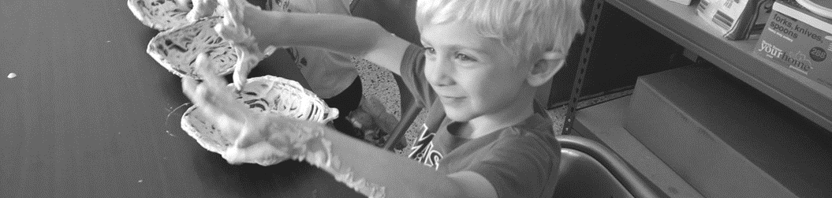

Discipline

Loving discipline is a normal part of our preschool program. The purpose of limits is twofold: safety and consideration of others. Techniques of behavior management used in the preschool include
- Positive Reinforcement
- Reflection or thinking time
- Teacher demonstration of appropriate behavior/play
- Redirection of child’s focus to other areas of the room or to other activities
- Verbal Warning
- Visit with the Director
- Biting is not tolerated - Thinking time is immediate

By using these techniques, children learn to redirect their energy into constructive outlets and learn to take responsibility for their own actions

Sometimes a parent conference is needed for behavioral issues with the teachers and/or the director. Parents may receive an email/text/call to schedule a meeting about children who use inappropriate/excessive physical force or biting as this may cause a danger to others.

1. First a staff member will email or call the family informing them about the student behavior. A plan will be put in place to try to reduce the behavior
2. Second, if a student continues to present with the behavior, the family will be contacted by phone and the student could be suspended from school for up to 3 days. No adjustments will be made to tuition. A plan will be put in place to improve the behaviors. If additional staff are needed there may be a fee for the families.
3. Finally, if a student returns and continues to have unmanageable behaviors that are a danger to others, the student may be asked to leave the school. No refunds will be made in regards to monthly tuition.

Updated April 2024

