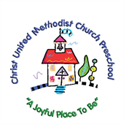

Illness Protocol

Here at Christ UMC Preschool, we continue to be vigilant of any symptoms of contagious illnesses.
- If students appear to become ill during the school day, they will be removed from the classroom, quarantined in the director’s office, and sent home.
- All areas they have been will be disinfected.
- Children who are sent home for an illness must be fever free for 36 hours without fever reducing medication before returning to school and be diarrhea free for 24 hours before returning to school or should have had a normal bowel movement.

Children should remain at home if they are showing symptoms of illness.
- Signs of illness, such as fever, sneezing, coughing, runny nose, sore throat, flushed face, headache, rash or diarrhea. If they don’t feel well then preschool will not be fun for them.
- We understand that some students struggle with allergies. However, children who have runny noses, watery eyes and coughs that look like they might have a contagious virus cannot attend the preschool. We encourage families to talk with your pediatrician about appropriate allergy medication so your child can come join us for some fun.

We continue to encourage children wash hands frequently, students can wear a mask at parents’ request and we wiping down toys and classrooms regularly.

Update 1/2023

